**Procedure for Installing Windows 10 in Rasberry-Pi4**

Step 1 --> Download and extract "WoR_Release_2.0.0-alpha.3_Patched_NoRamLimit" in your Laptop or Desktop

Step 2 --> Insert the SD card in your laptop

Step 3 --> Download the file "20201.1000_arm64_en-us_multi_13e52171_convert" to your Laptop or desktop

Step 4 --> Extract the file and execute "uup_download_windows". It will automatically open cmd prompt and download a ISO file in the same location where the uup_download_windows file was.

Step 5 --> Execute the file WoR.exe from "WoR_Release_2.0.0-alpha.3_Patched_NoRamLimit"

Step 6 --> Select Language -> Select your SD card and Raspberry Pi 4 --> Select the ISO image and type of windows Version (Home or Prof) --> The Firmware from Internet --> Driver from Internet --> and push the OS

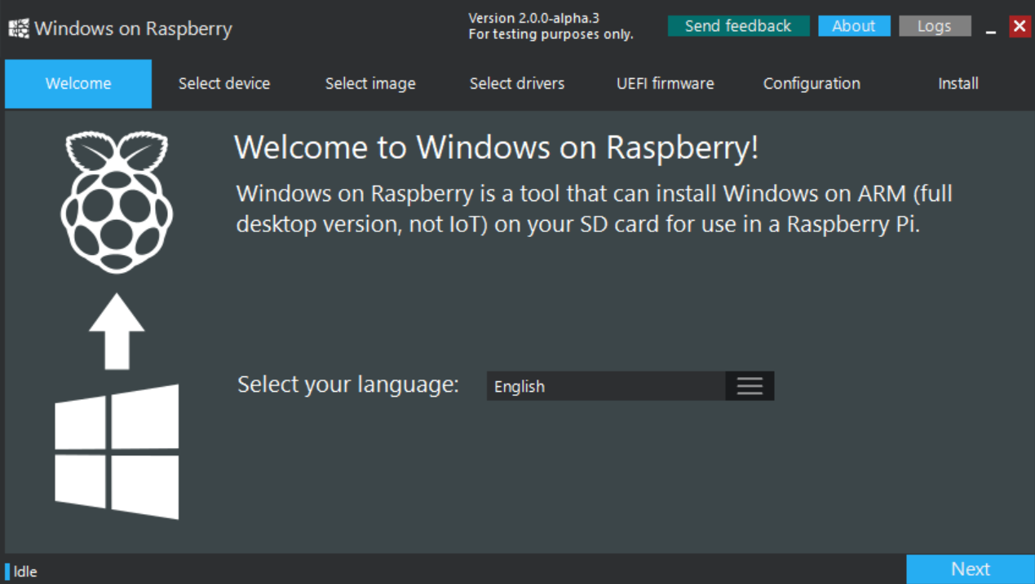

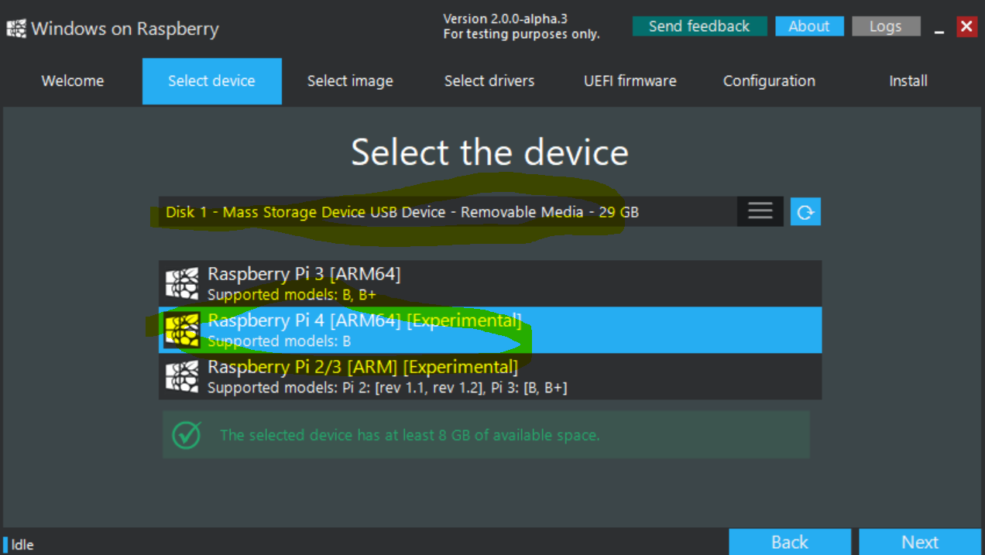

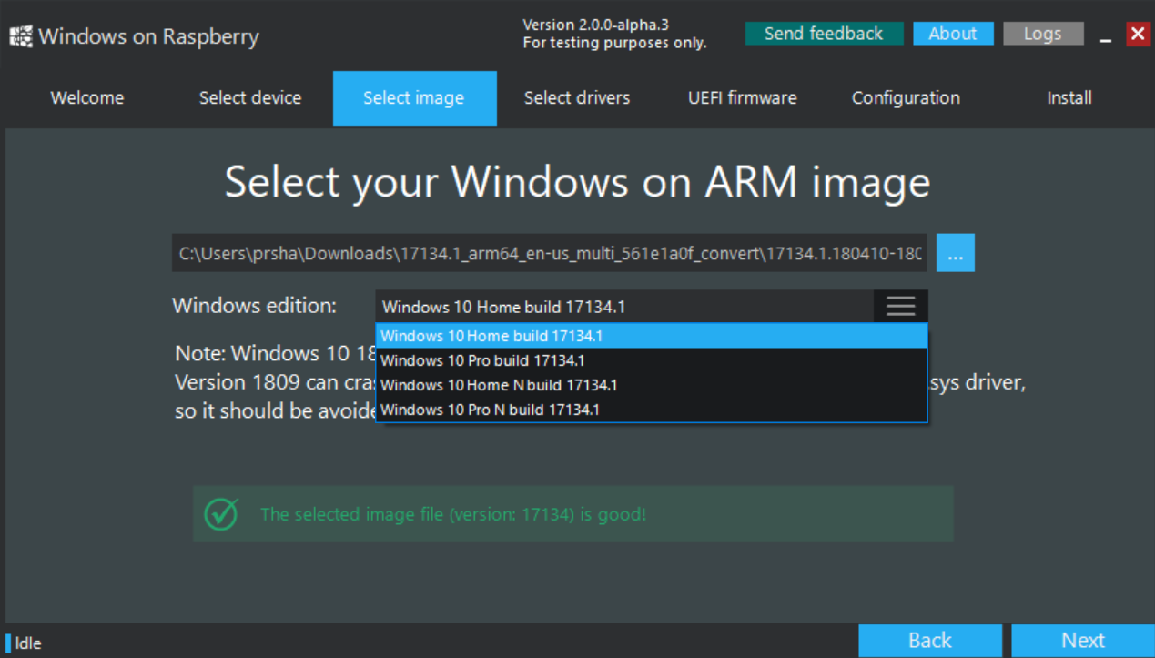

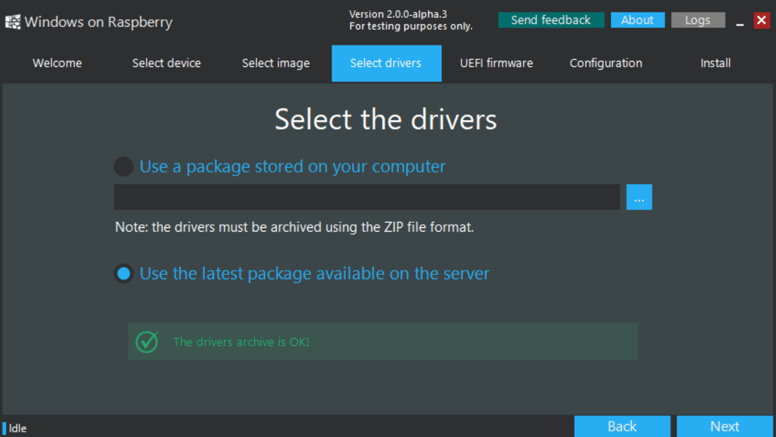

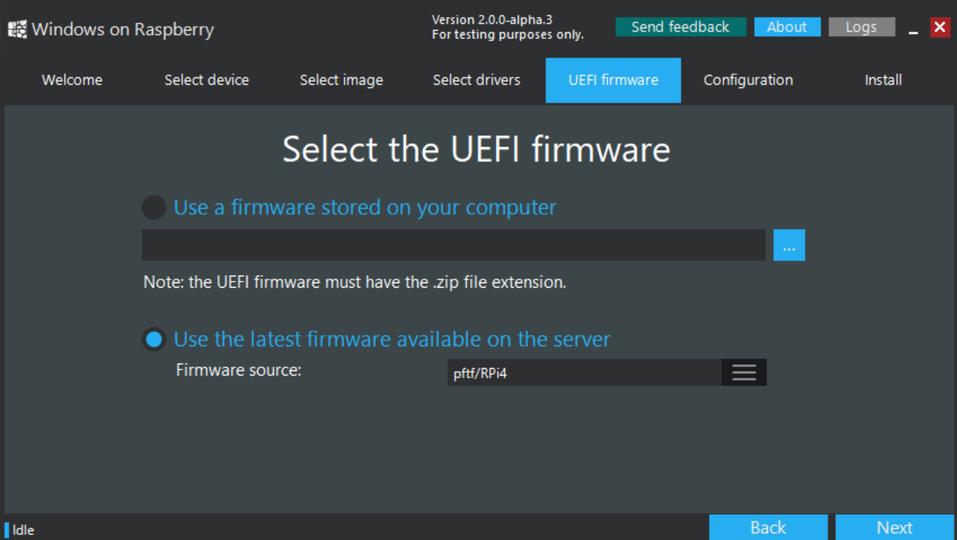

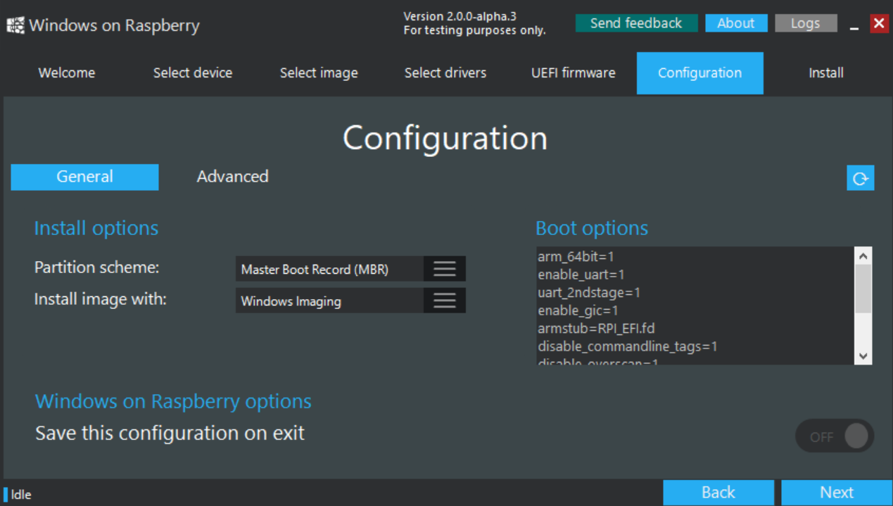

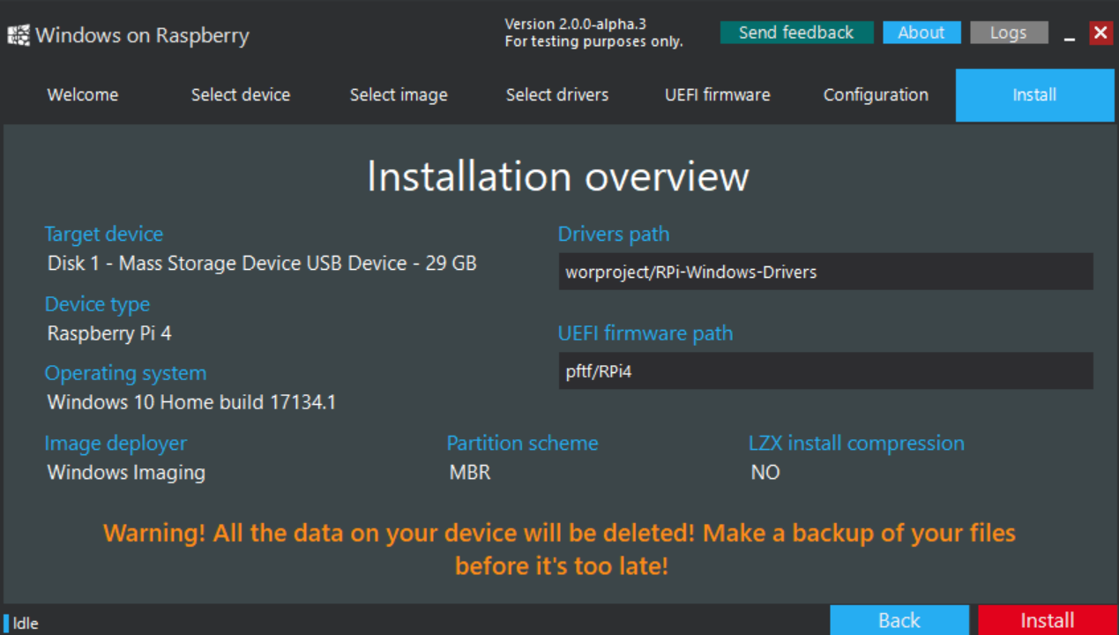

Step 7 --> Once finished remove the SD card and Insert it in your Raspberry Pi and Power On Wait for sometime as it boots

Step 8 --> Follow Windows Configuration

Note : Raspberry Pi4 will not have WIFI driver. You need to use Wired Connection. If you have Raspberry Pi3 B or B+ then WIFI will have driver.